2.

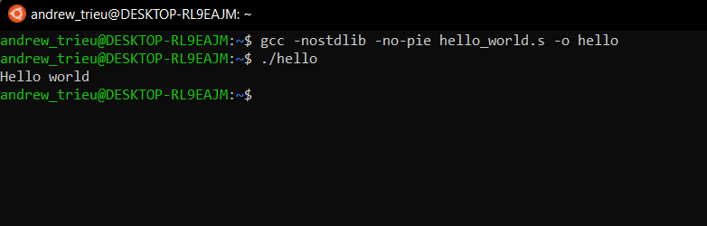

3.

a) msg: .ascii "Hello world\n\0"

syscall_write_opcode: .quad 1

b) movq $60, %rax

movq $0, %rdi

syscall

4. The program calculates x=[(N/x)+x]*x using 10 loops.

a)



b)

|  |  |  |  |  |
| --- | --- | --- | --- | --- |
|  | Add | Div | Sub | Mul |
| Floating point | 1.094s | 2.372s | 1.092s | 1.104s |
| Integer | 1.098s | 18.320s | 1.091s | 1.102s |

c) There are significant difference between the 2 data types when it comes to division.